**Homework 5: Enhancing Your Search Engine**

**Steps followed:**

1. Changes made to Solr configuration to handle autocomplete with SuggestComponent and SearchHandler.
2. Core reloaded and the changes made are verified on solr interface.
3. We use Big.txt which is extracted from several sites using online parsing sites and added into it. It is used as the vocabulary for spell check and auto suggest.
4. Peters Norvig’s SpellCollector.php is downloaded and included for spell check feature in our php code work.php.
5. Hence when a user inputs a query and submits the program checks to see if it’s a valid word. If the word is valid it simply displays the results, if it’s an invalid word it returns the closest word and also returns the results for it with “showing results for” with the closest term and “instead of” with the incorrect query term.
6. Autocomplete feature implemented using JQuery, requests solr suggest api for suggestions to the input query. Removes the stop words and displays the suggestions to the user.

**Examples for Spell Check:**

1.Ipheon-Iphone

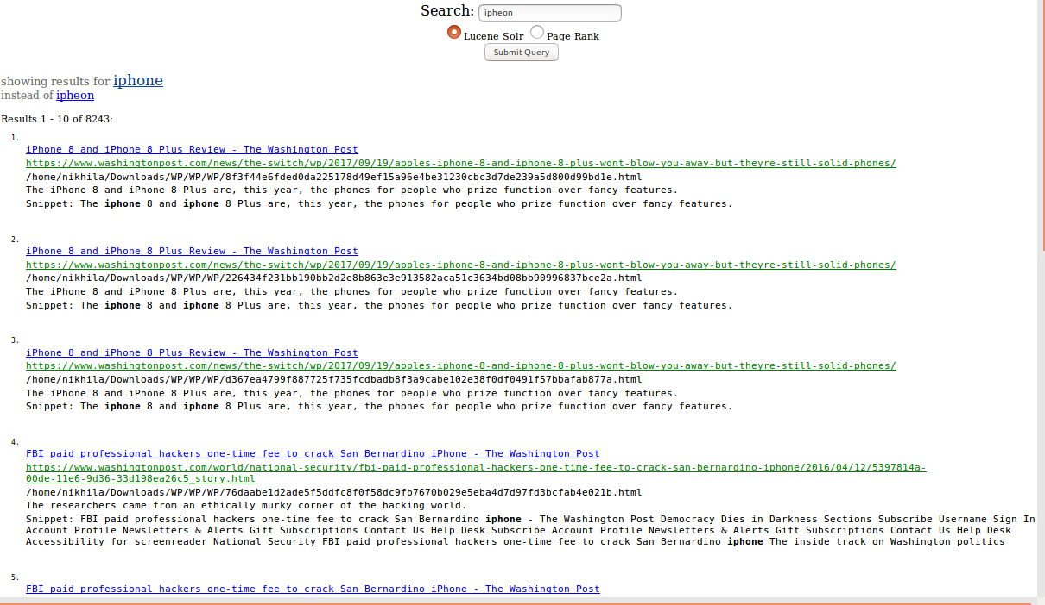

2. Californa- California

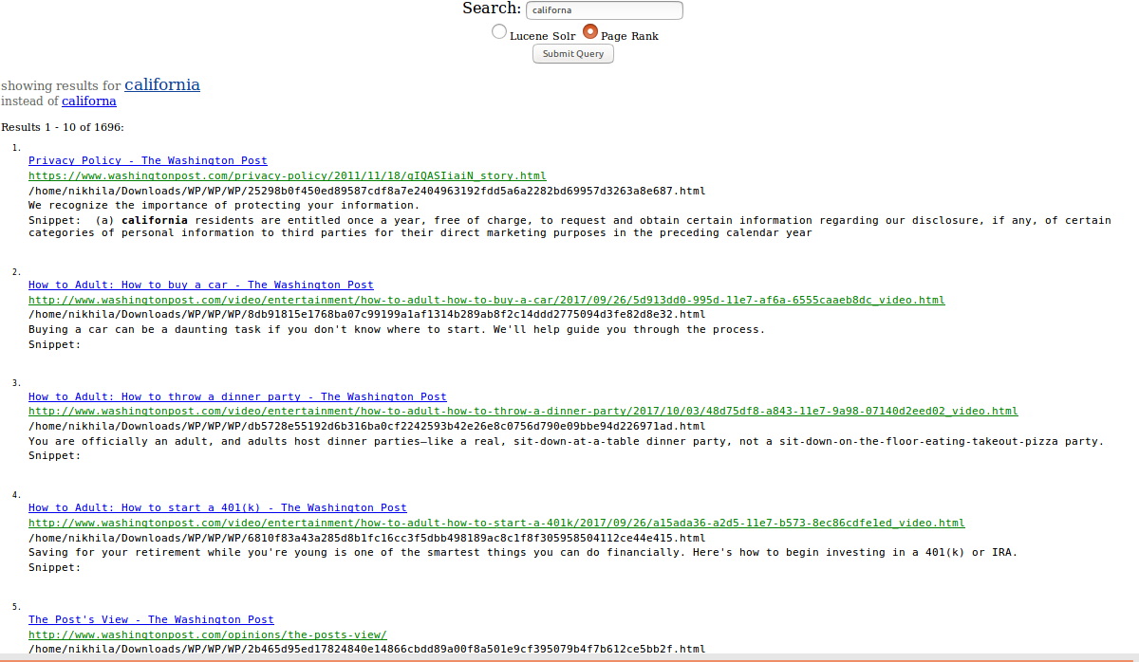

3. Donald trmup- Donald trump

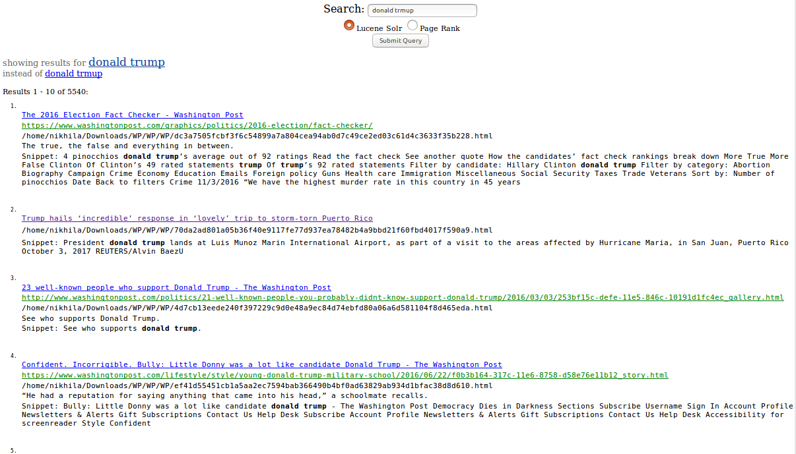

4. south korae- south korea

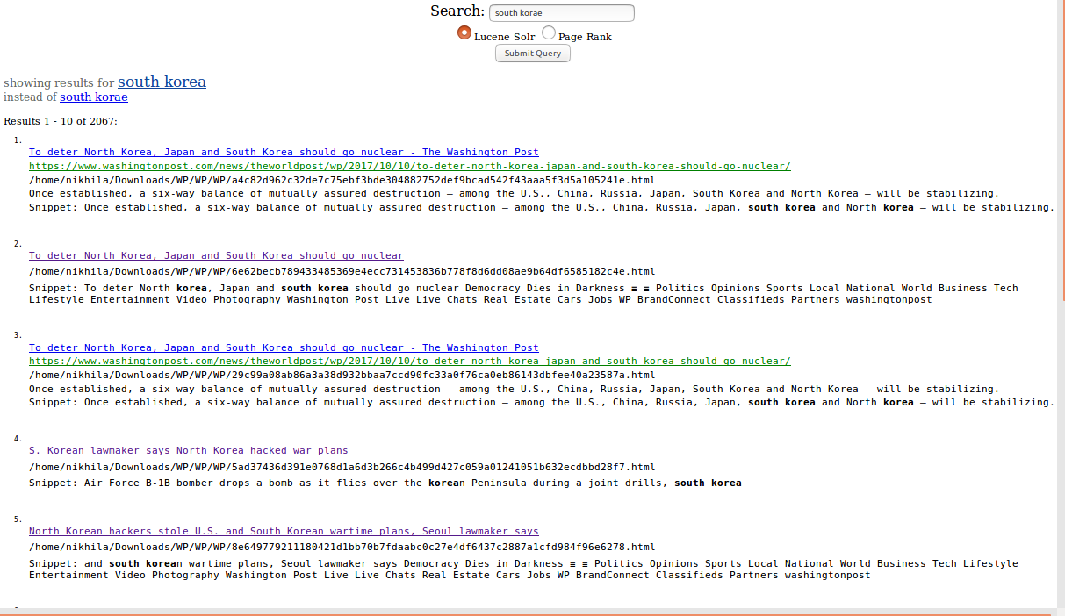

5. ocama- obama

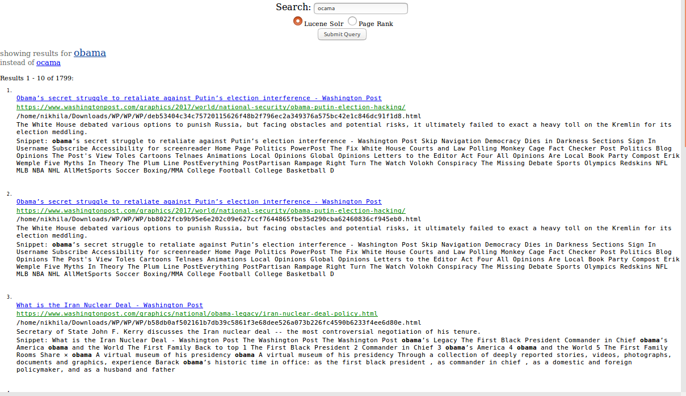

**Examples for Autocomplete:**

1. IPhone

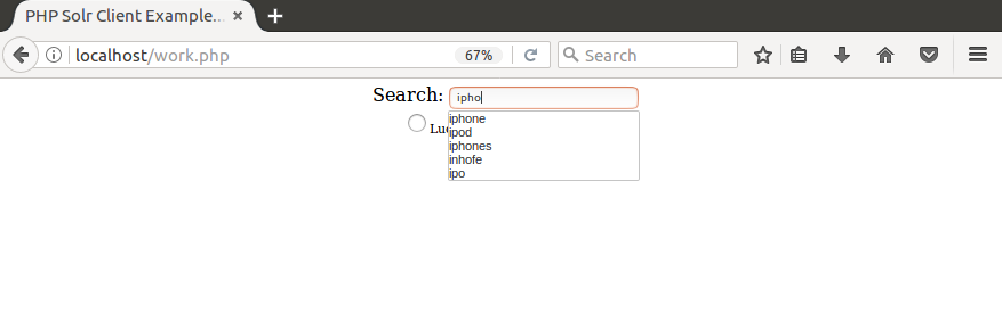

1. California

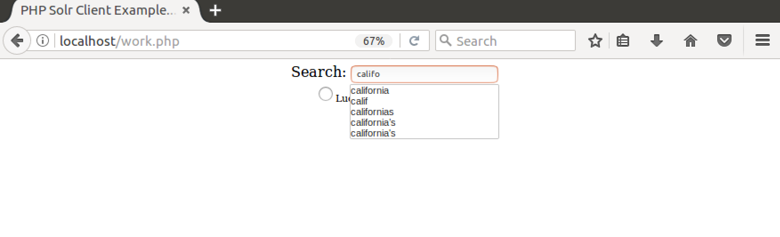

1. Donald Trump

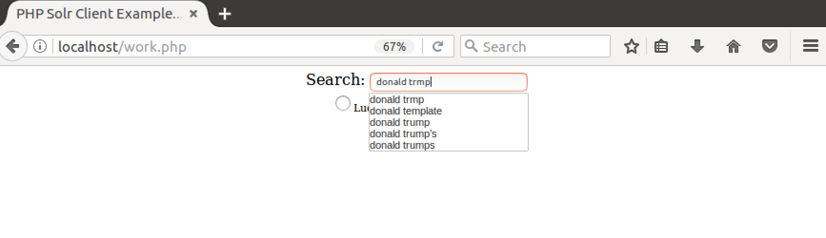

1. South Korea

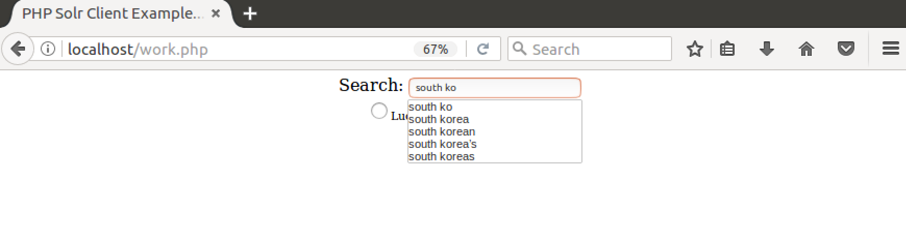

1. Obama

